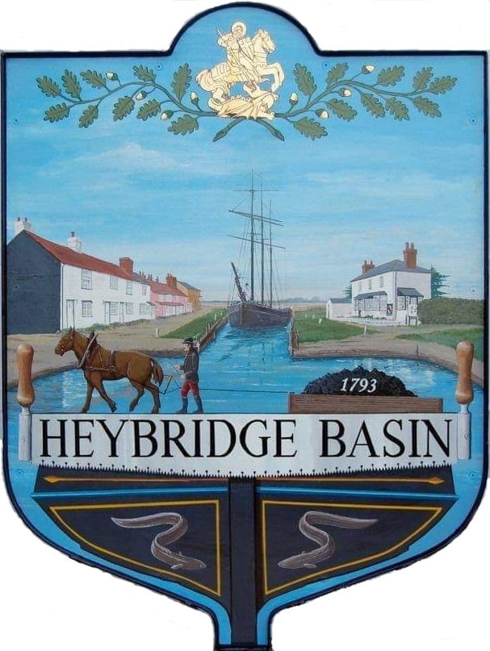

HEYBRIDGE BASIN PARISH COUNCIL

Minutes of the Budget meeting of Heybridge Basin Parish Council held on Friday 3rd November 2023 at 6.45pm, at The Lock Tea Room.

PRESENT

In the Chair: M. Hodges Apologies: C. Swann

Officers: G. Lake – Clerk
Councillors: J. Sjollema
C. Edmond Absent: 0
M. Hobden
R. Bryson Public: 0
G. Howat

It was noted that this meeting was being recorded by the Clerk.

23/98 Chair’s Welcome
Cllr Hodges opened and welcomed everyone to the meeting.

23/99 Apologies for Absence.
Apologies were received from Cllr Swann.

23/100 To receive Declarations of Interest in accordance with the Council’s Code of Conduct and with section 106 of the Local Government Finance Act 1992.
Cllr Hobden – Non-Pecuniary – HBSA, Basin Oars and HB Rivercare; Cllr Edmond – Non-Pecuniary – Essex Waterways, Director of Cloughton Court Management; Cllr Howat – Non-Pecuniary - HBCSA

23/101 Budget 2024/2025
- To draft the budget for 2024/2025 including identifying expenditure heads and their provisional costings and agree any action to be taken.
A discussion was held regarding the drafting of the budget for 2024/2025. Additional budget headings were identified. It was resolved to liaise with Row4AReason to discuss costings and locations of additional Defibrillators in the village. It was resolved to research costings and storage options for sandbags and salt boxes. It was resolved for the Clerk/RFO to circulate the updated spreadsheet for members to consider and discuss at the next meeting.

There being no further business the meeting closed at 08:43pm
Provisional Date of the next Council Meeting Tuesday 14th November 2023.

Clerk Contact details: clerk@heybridgebasinpc.org.uk
Website: www.heybridgebasin-pc.gov.uk

